Ramiro Francisco Batallas

[Email address]

Sitecore Hackathon 2021

Website developer with Sitecore 10.1

Wolfensteing team

User Guide

# Installation Instructions

1. Go to the Sitecore CM server. 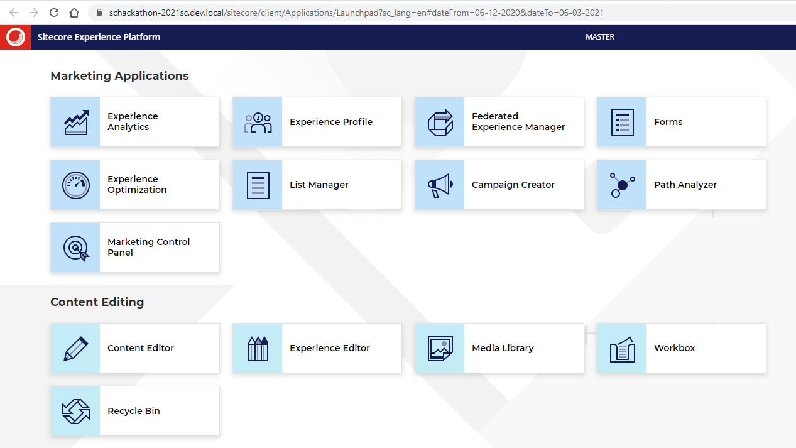
2. Click on Content Editor.
3. Go to the Home page.
4. Click on Show Editor. 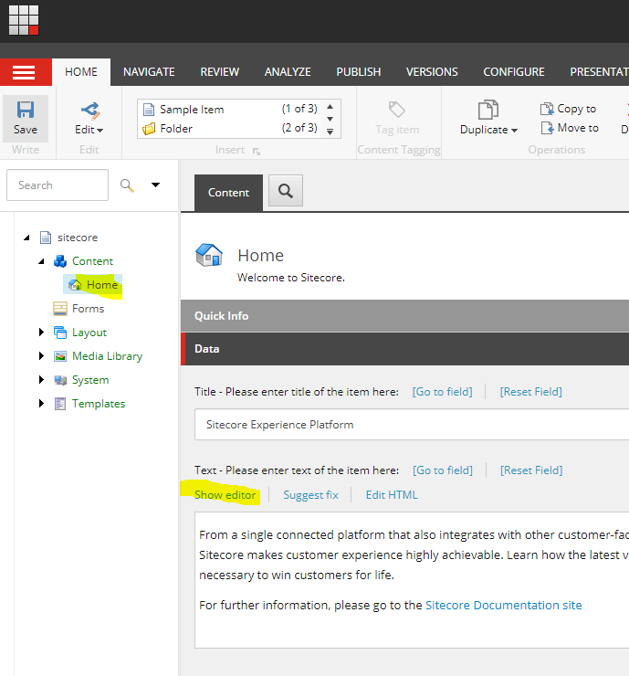
5. Create a new line and write something. For example. 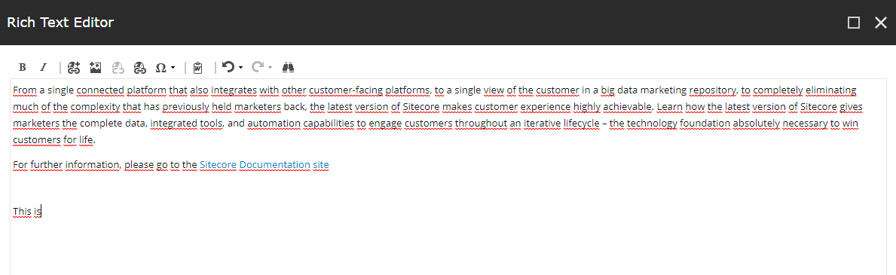
6. Press shift +white space.
7. A new list of suggestions should be appeared.

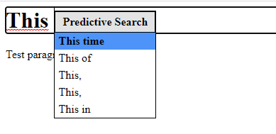

1. To select one of them, press ctrl.